FEBB’s 41st Anniversary Mark Your Calendar ! ! ! Apr 28 - 29, 2022 NEBB Certified Professionals * Firm Owners * Technicians * Spouses/Guests

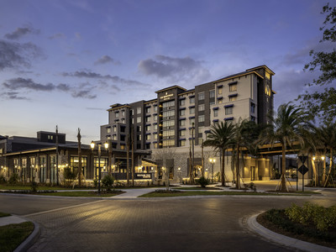
“FEBB Business Meeting & Re-Certification Conference”
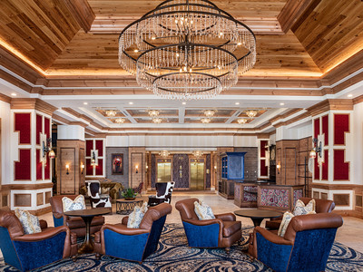

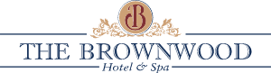
APRIL 28 – 29, 2022
{Conference Registration Email will be coming soon}
[Activities for Spouse/Guests! Gift Drawings at Thursday night dinner]
To make your hotel reservations contact the reservations department at the The Brownwood Hotel & Spa at 1-352-626-1246 & ask for the “Florida Environmental Balancing Bureau” Group Code: FEBBFL You must book by March 18th.

Run of House Guestroom – $159 per night (other room types are available)
Free Self-Parking; wireless internet in rooms & meeting space.
Not included: taxes which are currently 14.5%

